# Media Analysis - AI is not smarter than humans _ Updated 08 April 2023

## Short Summary

The article is about the growing use of AI tools like ChatGPT in personal and business tasks, with a discussion on its limitations compared to human intelligence and the need to maintain human connection despite advancements in technology.

## Summary

1. The individual expresses curiosity about AI tools like ChatGPT and their potential applications in personal life and business tasks.  
2. They have had positive experiences using various AI apps and consider themselves advocates for these technologies, praising the engineers who developed them.  
3. The first experience with AI was Siri in 2011, which helped with reminders and alarms. They believe that technology has progressed significantly since then, leading to virtual assistants capable of more complex tasks like brainstorming ideas.  
4. Despite its advancements, the individual believes that AI will never replace human connection, as it cannot understand or convey cultural nuances effectively, such as emotions during events like singing the national anthem. AI is seen as a tool to simplify workloads and generate innovative ideas but not as a replacement for humans.

## Question 1

In the given text, the media frames the discussion about AI, particularly ChatGPT, in a way that emphasizes its capabilities as a tool to enrich personal and professional life. The metaphor of AI as a virtual assistant is frequently used, with examples such as recruiters, marketers, CEOs. The text also suggests a positive outlook towards AI, referring to it as something that could revolutionize business operations like the internet did. However, there are concerns raised about AI s limitations in understanding complex human emotions and cultural nuances, using the metaphor of AI being unable to capture all that comes with events such as national holidays or express personal feelings like pride. The text also suggests a sense of awe towards the advancements in technology, using the metaphor of a smaller world due to increased connectivity. Finally, there is an emphasis on the essential human connection and the irreplaceable role of humans, even with AI assistance.

## Question 2

The text discusses various perspectives on Artificial Intelligence AI from a personal and professional point of view. Widely covered topics include 1. AI s potential to enrich personal lives by helping with tasks like reminders and brainstorming ideas. 2. AI s impact on business operations, particularly in marketing departments. 3. The progress of AI technology over the years. 4. Concerns about AI s future utilization, reliability, and connection with humans. 5. The role of humans and AI working together in a mutually beneficial relationship. 6. AI s limitations in understanding culture, emotions, and the personalized aspects that only humans can provide. 7. The evolution of human-AI interaction and communication, particularly in regards to language barriers. Aspects that are being ignored or not explicitly addressed in the text include 1. Technical details about how AI operates and learns. 2. Potential negative impacts of AI on employment and privacy. 3. Ethical considerations and regulations surrounding AI use. 4. The potential for AI to surpass human intelligence or become autonomous. 5. Long-term societal changes due to increased reliance on AI technology.

## Question 3

Not mentioned. The article discusses the author s personal experiences with AI technology, but it does not mention any specific role or application of AI in the Arabic world.

## Question 4

The article emphasizes that while AI can assist and enrich our lives, it will never replace human connection and understanding. It acknowledges AI s potential in aiding various aspects such as business operations and marketing, but underscores its limitations in capturing the full essence of human experiences like culture and emotions.

## Sentiment

The sentiment is 4.0

## Entities

Saleh, Tay, Apple, Saint Marys University, Ali Al-Mustafa, Microsoft, Twitter, Oracle, Google Translate, SAP

## Highlights

#7cc867#fb5b89#f9cd59

## Wordcloud for #7cc867 Highlights

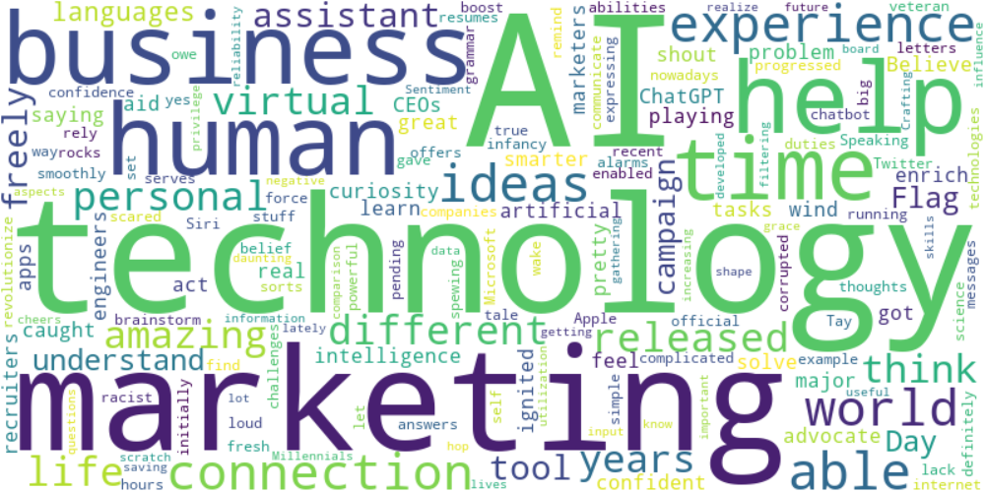

Top 10 words:

- AI: 10

- technology: 8

- marketing: 6

- like: 5

- business: 4

- humans: 3

- experience: 3

- able: 3

- ideas: 3

- connection: 3

## Wordcloud for #fb5b89 Highlights

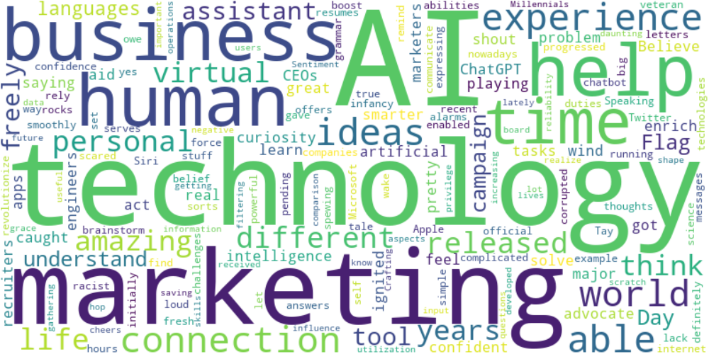

Top 10 words:

- AI: 10

- technology: 8

- marketing: 6

- like: 5

- business: 4

- humans: 3

- experience: 3

- able: 3

- ideas: 3

- connection: 3

## Wordcloud for #f9cd59 Highlights

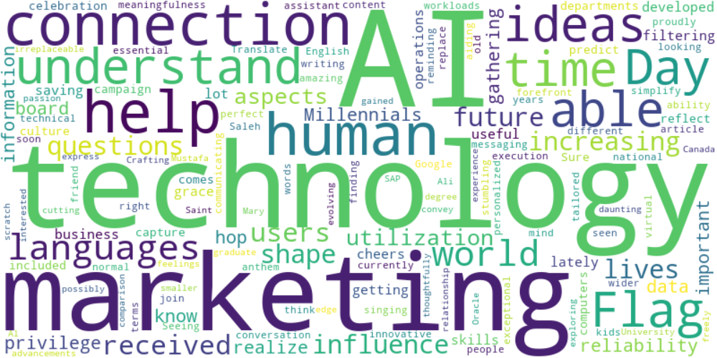

Top 10 words:

- AI: 6

- technology: 5

- marketing: 4

- connection: 3

- help: 3

- like: 2

- humans: 2

- understand: 2

- able: 2

- ideas: 2